**Encrypting Database:**

Website Link: <https://www.npmjs.com/package/mongoose-encryption>

1st of all, install mongoose-encryption in the console npm i mongoose-encryption

2nd , in .env write the secret code

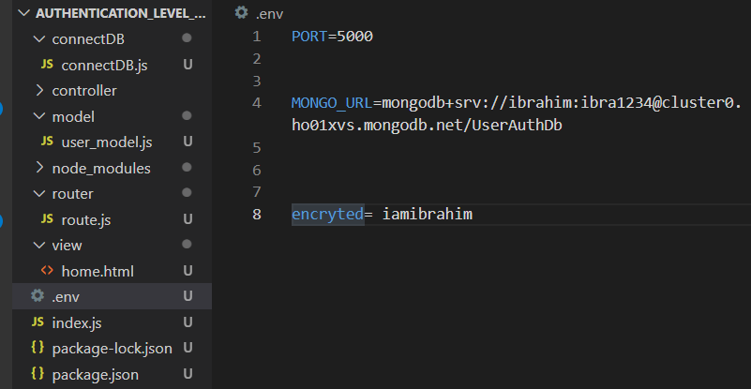

Then go to the model section and in schema and write the code,

let mongoose=require("mongoose")

let encrypt=require("mongoose-encryption")

Require the mongoose-encryption

require("dotenv").config()

let user_Schema= mongoose.Schema({

    email:{

        type:String,

        required:true

    },

    password:{

        type:String,

        required:true

    },

Get the secrect encrypted value from dotenv file

    created_at:{

        type:Date,

        default:Date.now()

    }

})

var encKey = process.env.encrypted;

Secret encrypted code

user_Schema.plugin(encrypt, {

secret: encKey,

Which field we want to encrypted

 encryptedFields: ['password'] });

module.exports=mongoose.model("user_info",user_Schema)